Shabbos Stories for
Parshas v’eschanan 5780
Volume 11, Issue 47 11 Menachem Av/August 1, 2020
Printed L’illuy nishmas Nechama bas R’ Noach, a”h

For a free subscription, please forward your request to keren18@juno.com
Past stories can be found on the website ShabbosStories.com

INCREDIBLE WWII STORY
Sometimes, It’s Not
Really Just Luck

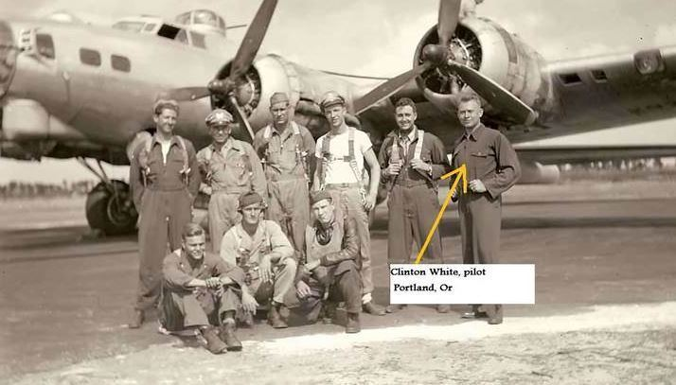
Photo of a B-17 warplane from the Second World War

This story is confirmed in Elmer Bendiner’s book, “The Fall of Fortresses”. Elmer Bendiner was a navigator in a B-17 during WWII. He tells the story of a World War II bombing run over Kassel, Germany, and the unexpected result of a direct hit on their gas tanks.
“Our B-17, the ‘Tondelayo’, was barraged by flak from Nazi anti-aircraft guns. That was not unusual, but on this particular occasion our gas tanks were hit. Later, as I reflected on the miracle of a 20 millimetre shell piercing the fuel tank without setting off an explosion, our pilot, Bohn Fawkes, told me it was not quite that simple.

A Souvenir Sheet of Unbelievable Luck
On the morning following the raid, Bohn had gone down to ask our crew chief for that shell as a souvenir of unbelievable luck.
The crew chief told Bohn that not just one shell but 11 had been found in the gas tanks. 11 unexploded shells where only one was sufficient to blast us out of the sky. It was as if the sea had been parted for us.
A near-miracle, I thought. Even after 35 years, this awesome event leaves me shaken, especially after I heard the rest of the story from Bohn. He was told that the shells had been sent to our armorers to be defused.
The armorers told him that our Intelligence Unit had picked them up. They could not say why at the time, but Bohn eventually sought out the answer. Apparently when the armorers opened each of those shells, they found no explosive charge. They were as clean as a whistle and just as harmless.
Empty? Not all of them! One contained a carefully rolled piece of paper. On it was a scrawl in Czech. The Intelligence people scoured our base for a man who could read Czech. Eventually they found one to decipher the note. It set us marvelling.
Translated, the note read: “This is all we can do for you now… Using Jewish slave labour is never a good idea.”

Reprinted from the Parshat Mattos-Masei 5780 email of Oneg Shabbos (London, U.K.)

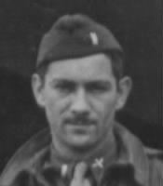
Elmer Bendiner
Elmer Bendiner (February 11, 1916 – September 16, 2001) was an American writer and journalist. Bendiner was born in Pittsburgh to William Bendiner, a businessman, and Lillian (maiden name Schwartz). His brother was Robert Bendiner.
Growing up Jewish in an Appalachian environment where the Ku Klux Klan was influential and "Jews, Catholics, and the very few blacks on the outskirts of town ... served as ritualistic enemies" helped shape him.^{[1]}

He attended City College of New York from 1932 to 1935, then met Esther Shapiro, an editorial assistant, while he was working for the Brooklyn Daily Eagle; they were married in 1941, shortly before the U.S. entered World War II.
During the war, Bendiner served as a B-17 Flying Fortress navigator, receiving the Distinguished Flying Cross, the Air Medal with three oak leaf clusters, and the Purple Heart. (Reprinted from Wikopedia).

The Non-Jew Who
Wanted to Study Gemara

In Russia during the reign of Czar Nicholas, Count Oberov was the Minister of Culture, and he was known for his many talents and genius intellect. One of the Count’s close contacts was a Jew, Dr. Lillianthal, who, in conversation, would often quote from Mishnah and Gemara.
It reached a point where Oberov’s curiosity got the better of him, and asked to be taught some Gemara so that he could see the Torah of the Jews for himself. Dr. Lillianthal consulted with his colleagues, and decided that they would present the Sugya (topic) of the Tagrei Lod, the Merchants of Lod, which is found in Bava Metzia (50a), reasoning that it would be understandable to the Count as it required no prior knowledge of Gemara or Talmudic method of reasoning, and it contained no Scriptural references.

Preparing the Sugya in a Simple,
Clear and Concise Manner
Having prepared the Sugya simply with its fundamentals and organized all the opinions and explanations in a clear and concise manner, Lillianthal met with the Count to teach him the Gemara.
During the entire discourse, Oberov sat with his hands supporting his head while he struggled to understand the topic. When Lillianthal finished, the Count appeared drained and exhausted from straining his mind, and he asked the doctor to repeat what had been taught and to explain the Sugya again.
Upon finishing a second time, Oberov stood up from his place, and with a broken spirit and great distress, exclaimed that he just didn’t understand. There was no end to his pain when he asked the doctor if this was a particularly difficult piece of Gemara, to which Lillianthal answered that this Sugya was actually easily understood by every Yeshivah student.
It was thus apparent to Oberov, Minister of Culture to the Czar, that with all his abilities, he did not reach the intellect of a Yeshivah boy! When the Netziv would tell over this story, he would be asked how Oberov— someone who was known for his brilliance and exceptional skills, was not capable of understanding this simple topic? The Netziv would answer that it is no wonder, as the Gemara in Sanhedrin (59a) teaches us that the Torah is a legacy for us only, and not for any gentile. The Torah is incomprehensible even for a smart goy. This is also stated in Medrash Eicha (2:17) that Torah does not even exist among the goyim!

Reprinted from the Parshas Mattos-Masei 5780 email of Torah U’Tefilah as compiled by Rabbi Yehuda Winzelberg.

Asking His Talmidim for Permission to Miss a Shiur

Rav Mordechai Rogov, zt"l, Rosh Yeshivah of Bais Medrash L'Torah in Skokie, Illinois, was a distinguished Torah scholar and Mussar personality, and following World War II he moved to Chicago.
During his tenure as Rosh Yeshivah, he reached out to many Talmidim (students), instilling in them a love of Torah. What his Talmidim recall about him most was the love and respect that he demonstrated towards them. He was warm and caring, making every student feel comfortable in his presence.
Rav Rogov never turned his back on a Talmid. After speaking with a student, whether it was in the Bais HaMedrash or in a classroom, he would always back away when he had finished. He did not turn around and leave with his back to the student.
This taught the Talmidim to respect and show reverence to those who study Torah. He once announced to his class that since a student was expected to inform his Rebbe if he could not attend class, it was only right that the Rebbe should notify his Talmidim if he was going to miss Shiur.
He explained that his grandson was becoming Bar Mitzvah that Shabbos in Detroit, and he would like to attend, only if his Talmidim did not mind. If anyone had objected, he would not have attended his grandson's Bar Mitzvah! After being assured that no one minded if he would miss Shiur, he only then agreed to go with his family to the Simchah!
Reprinted from the Parshas Mattos-Masei 5780 email of Torah U’Tefilah as compiled by Rabbi Yehuda Winzelberg.
A “Chance” Encounter
By Rabbi Sholom DovBer Avtzon

Rabbi Simcha Zirkind approached Dovid Wilansky and me and asked us if we were willing to go on Merkos Shlichus to New Brunswick, Nova Scotia, and Newfoundland. We agreed and he gave us names of people in various villages, towns, and cities to visit. Those people would help guide us to other Jews in their vicinity and we would work off of that as our base.

Since it was prior to GPS days, we took out a map and mapped out our trip. The first stop would be in Moncton, New Brunswick, then Halifax, Nova Scotia, a sixteen hour ferry ride to Argentia, Newfoundland, which is close to its capital S. Johns where there is a Jewish community.
These were the largest cities in regard with Jewish families, and on the way back we would visit smaller towns and villages. The final visit was in a small town in New Brunswick, where we were supposed to meet the only Jewish family living there who owned a hardware or country store and was a supporter of the Yeshiva.
Arriving at the store on Thursday around two in the afternoon, we were informed that the owner and his married children had gone on a vacation and would return the following Tuesday. Disappointed, we asked the clerk if there is another Jew in this town or nearby town or village.

The Clerk Believed There was
One Other Person Who was Jewish
The clerk replied that he believes there is one other person who is Jewish and gave us the address and directions to his house.
As we pulled up to the driveway in the decorated mitzvah mobile, I noticed a man coming out the door holding his briefcase and staring at us in bewilderment. He waited by the door which he had not closed and asked us to come in. I thought it would a brief conversation since it seemed that he was heading out when we arrived.
When we began explaining that we are from Lubavitch he said that he knows of Lubavitch. He then asked if we knew a certain person. When we replied no, he was surprised and said, “Lubavitch is in Crown Heights, he lives in Crown Heights and you don’t know him?!”
I responded that I am from Michigan and besides family and some friends who live in Crown Heights, how am I to know him? Dovid replied that although he is from Crown Heights and perhaps his parents know that family, he only knows the people on his block, those who daven in the same shul, and of course family and classmates, but he doesn’t know him.
“You really mean you didn’t speak to him lately,” he asked in astonishment?
“No,” we replied. “We were on the road for the last month visiting the outlaying Jewish communities in these three Canadian Provinces, and after here we are going back to Montreal. We haven’t spoken to anyone in Brooklyn during the past four weeks.”

He Couldn’t Believe It
“I don’t believe it,” he replied. “It is so uncanny.”
“You see that person is my brother-in-law. He was inspired by his local Chabad – Lubavitch representative and he became religious and Chassidic just like you. Over the past few years, before the holidays, he sent us brochures about the holidays and some Jewish books for our children to read, trying to draw us in.
In the beginning it was amusing, but he began trying to push us, so we wrote him that you say wherever there is Coca Cola, there is Lubavitch. We are living in this community for almost ten years, there is plenty of Coca-Cola, but there was never a Lubavitcher here. So please, give us a break.
His reply came to us yesterday and he wrote, “Who knows , one day they will show up at your doorsteps. That letter arrived yesterday, and now you are here, one day later. That is why I waited by the door when you arrived and although I am going to come in late to work at my job at the border patrol. I wanted to hear about my family.”
However, the conversation didn’t end then, as it went on for over an hour. He then said, “My wife and I have this question that we ask every Rabbi that we meet, and because of this question we are non-observant. Therefore since you are two young men, studying to become Rabbis, I will ask you the question.

I Can Understand that G-d Could
Be Displeased By My Actions
We understand that G-d could be displeased with the actions that an individual or group does. Sometimes He lets it go and sometimes He punishes the person. So if I personally become sick, I accept it. G-d is telling me He is unhappy with my actions and decisions and is punishing me. I deserve it, and I can accept it.
However, when a child is born with birth defects or an illness, the child is innocent and pure, he didn’t do anything wrong. Why would a kind and loving G-d and Creator do such a thing to the innocent? It is because of this question that we don’t observe the commandments.”
I was at a loss. If all the numerous Rabbis they asked couldn’t give a satisfactory answer, how could we? But Dovid replied, “I had the same question and two years ago when I was learning in Morristown, I asked it to the dean, Rabbi Heber.
He replied as follows, ‘A good question is half the answer. You say you understand if it happened to an adult, since that is in middle of their life and it is possible that they sinned against the Creator. A child on the other hand, is at the beginning of its life. But if this child would become sick G-d forbid in middle of his life, everything is understood from your perspective

Most People Nowadays are in
The Middle of Their Journey
So therefore you should know that most people nowadays are in middle of their journey. They are a reincarnation of an individual who had already lived, but their soul was sent back to this world to complete their mission. They erred in something or didn’t fulfill something. So yes, the newborn is an innocent child, however, its soul is not new; it is in middle of its life and therefore, G-d in His wisdom, does what He does.’”
The couple thanked us for the response and replied that they will discuss it and think it over.
The following year when two other young men went on Merkos shlichus to the same towns, they asked us for tidbits of advice etc. I told them that if it were possible, they should visit this couple and they would have an enjoyable conversation.
When they returned I asked them how it went and who were they able to visit.
“We met the couple that you advised us to visit. However, we didn’t have to go to their town, we met them in the Yeshiva in Montreal.”
Seeing my expression of disbelief they continued, “They were speaking to Rabbi Hendel and told him that last summer two students of the yeshiva visited them and gave an answer to their question and they thought about it and came to the conclusion that G-d is vindicated. Therefore as honest people they are now keeping their part and wish to become observant.”

Reprinted from the Parshat Mattos-Masei 5780 email of Rabbi Sholom DovBer Avtzon’s Weekly Story.

How a Motherless Widow Embraced Kindness
By Sofya Sara Esther Tamarkin

When I was a little girl, I used to love hearing my grandmother retell a Yiddish folktale about a miserable couple living in their cramped quarters with their many children.
They went to seek rabbinical advice and were surprised to hear that to solve the issue they need to bring a goat inside the house. The family was confused, but did as they were told by the sage. With this addition, they became even more miserable.
The family returned to clarify what to do and astonishingly were advised to bring a sheep into the house. This went on until they had an entire barn inside the house. Finally, the house had become utterly unlivable and they went to beg the rabbi for help, and only then did the rabbi tell them to let all the animals out of the house.
The couple did so and was ecstatic to be living in their now-spacious-feeling dwelling with just the family. Clearly, they were back to the beginning, but with a new perspective.
My grandmother taught me about life by sharing meaningful stories such as this one. Life can always get worse, yet we have an opportunity to transcend our limitations and look at the bright side of things, regardless of circumstances.
Some might say that the death of a 95-year-old woman should not be shattering. After all, at some point, death is no longer an unforeseen phenomenon but a natural occurrence. Yet a lifetime of wisdom could not prepare me for the loss of my grandmother, Zelda bas David, who passed away on May 6, 2020. Her vibrant spirit transcends her actual years on this earth. How can a heart so full of goodness and resilience just simply stop beating?

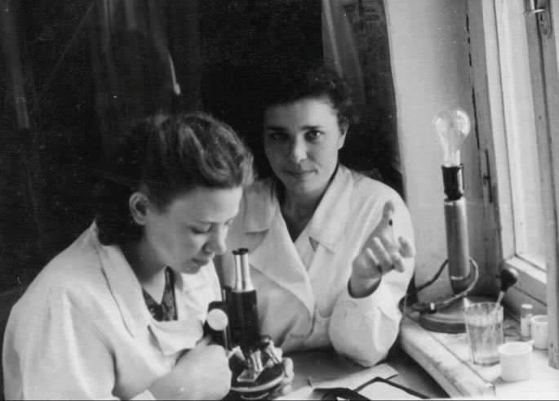
My grandmother (at the microscope) as a young doctor in the Soviet Union.

My grandmother’s life taught me that as a container is defined by its contents, life is identified by how one spends precious hours, days, years and decades.
Cultures, history and generations are divided by societal differences, yet kindness brings one unified identity to all humanity. Zelda was born a lifetime ago in July of 1924 in the former Soviet Union. Those were unsettling times, right after the Communist Revolution.
The world was recuperating from the Great War before confronting the horrors of World War II and the Holocaust. Her mother died in childbirth when Zelda was just 3 years old. Zelda and her two sisters were raised by her loving (and forever exhausted) father, who worked around the clock to feed his three little motherless daughters.
My grandmother was the kindest person I have ever known. Most people remember her as a generous, dynamic and energetic woman. Perhaps people who lived through wars, starvation and poverty had a special passion for giving to others. Their experiences made them want to make life easier for others.
Zelda often repeated the story about a little boy sitting on the stoop in the neighborhood. It was the early 1930s; these were the years of Stalin’s oppression and unbearable hunger. The boy was covered in lice, begging for food. Zelda’s heart was racing as she ran inside the house yelling, “Papa, I want to give my day’s ration of bread to the poor child outside.”
Her own hunger couldn’t stop her, as she snatched a piece of bread and ran into the street. The boy grabbed the bread with both hands, stuffing it into his mouth. Zelda often thought about that boy, remembering how hungry and weak he was.

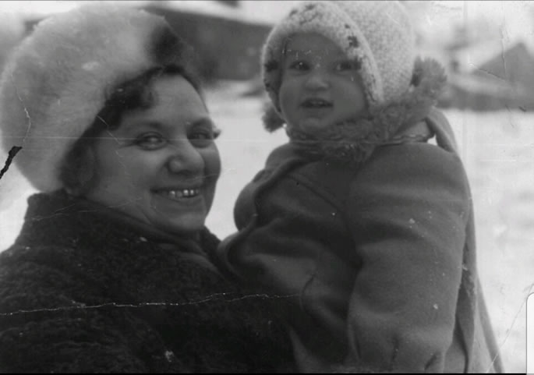
My grandmother and I during the cold winters in Saratov.

There was always a long pause after this story. Zelda was reliving this incident again and again. As a child, I felt sad for the hungry boy, and I wanted to know what happened to him. I asked for my grandmother’s reassurance that the boy survived. Yet unlike her own life, she didn’t sugarcoat the suffering of others. “I don’t know what happened,” she answered again and again, looking dazed. “I wish I could have done more for him.”
Later in life, Zelda became a doctor, saving countless lives. She married and had two daughters. Then, at 34, she became a widow when her husband died in a horrific drowning accident. A year after, her youngest daughter, who was 8, year fell off a slide and suffered a traumatic brain injury, becoming handicapped for life. A motherless widow with a sick child, she continued to march on through her personal obstacle course.
Zelda spent 12 years of her life in and out of hospitals, doing everything possible to save her daughter’s life. Despite the unimaginable struggles, her spirit remained unbroken. Almost every picture we have of my grandmother is of her feeding someone—cooking, smiling, singing, hugging, dancing or laughing with her entire being. Perhaps this incredible zest for life made it possible to survive these unimaginable challenges.
Our Jewish traditions teach us about the importance of positivity and internal joy. The book of Psalms sings to us to “serve G-d with happiness!” The Talmud praises those who perform commandments joyously. Famous personalities such as Rabbi Yehudah Halevi, Maimonides, Bachya ben Asher all discuss joy as a Divine service.

The Legacy of the Baal Shem Tov
Rabbi Israel Baal Shem Tov (1698-1760) revolutionized the world by his teachings on how to celebrate life. He entered a sad, dreary world and broke through its melancholy by explaining that every soul can find a path to the Creator through love and positivity. The Baal Shem Tov taught that every event that befalls a person—everything a person sees, hears and experiences—is an opportunity to connect to the higher consciousness. Since joy is the key that opens the door to connection and purpose, it’s incredibly important to feel inner happiness.
During these complicated and uncertain times, before I fall asleep I imagine my grandmother reminding me to learn to narrate my life with positivity and gratitude. I hear her voice reassuring me that “all the memories and experiences that have been accumulated along the way can be rechanneled into a vehicle of light and kindness.”

Listening to that Inner Voice
I listen to this inner voice and hope that my generation will spend our lives on giving, loving and transcending the narrative of our struggles. ​​As I think back to the folktale about the family that brought the animals inside, I imagine that, just like this couple, we, too, will experience a new attitude and appreciation about our lives. Perhaps we are healthy, productive, prosperous, content and vibrant, yet unaware of our blessings.
Just as Zelda dressed up her challenging life into a colorful rainbow of joy and gratitude, I hope and pray that all of us will emerge victorious from this challenging period, embracing kindness and empathy.

Reprinted from the Parshat Devorim 5780 email of Chabad.Org Magazine.
Rav Moshe and
True Tzedakah

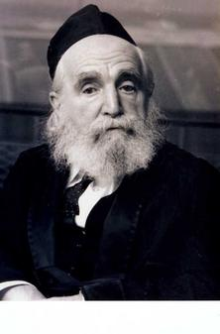
Rav Moshe Feinstein, zt”l, was once on his way to an important meeting when someone approached him and asked for Tzedakah. Although he was in a hurry, Rav Moshe took out his wallet and handed the man some money.
Thankful for the donation, the Yid began talking to the Tzaddik for a number of minutes, while Rav Moshe listened patiently. Finally, the man finished, and Rav Moshe continued on his way.
One of the accompanying students then asked Rav Moshe why he used so much of his precious time to listen to the man, and asked, “Wouldn’t it have been enough to simply just give him some money and left?”
Rav Moshe answered, “My talking to that man was far more important to him than the money I gave. The Mitzvah of Tzedakah also includes showing that you care and are interested in the recipient, and that you are not too busy to listen!”

Reprinted from the Parshas Bamidbar 5780 email of Torah U’Tefilah as compiled by Rabbi Yehuda Winzelberg.

Being Affected by
The Disciple’s Pain

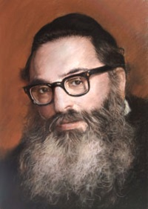
Rabbi Yitzchok Hutner

Rabbi Frand tells over a story he heard over from Rav Shiya Fishman, the Executive Vice-President of Torah U’Messorah. Rav Fishman had been a student of Rav Yitzchok Hutner (1907-1980) and related the following beautiful story involving his teacher.
When Rav Fishman was a young man in Kollel, he had a child with a serious medical situation. He went to his Rebbe, Rav Hutner, and unburdened himself with his personal problems — to the extent that he broke down in tears and covered his face with his hands. After a few minutes, when he recovered, he looked back at Rav Hutner and saw that Rav Hutner too was crying. The disciple’s pain was the teacher’s pain. The disciple’s tears were the teacher’s tears.
If one ever wonders why Rav Hutner was so successful in raising hundreds of such special students the reason is clear. Rav Hutner was not merely a teacher to his friends’ children – he was their father as well! The Torah is referring to this type of Rebbe, when it refers to Moshe as the father of Aharon’s children. This trait of Rav Hutner is what we should emulate on these days when we learn Pirke Avot to better our character.

Reprinted from the Parashat Bamidbar 5780 email of Rabbi Amram Sananes as written by Jack E. Rahmey.
A Most Unique Sefer Torah

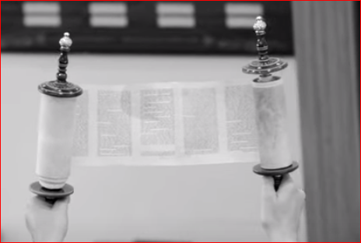

Rabbi Yoel Gold told another amazing story about a young man named Stuart who had his life changed for the better because of Torah. Stuart was not a religious man, but when he was about 35 years-old, he and his friends were offered a free trip to Israel, and they jumped at the opportunity to go.
They arrived in Israel on a Friday, and the next morning they thought they’d start touring. However, when they left the hotel that Shabbat morning they noticed the entire city of Jerusalem was completely quiet. There were no cars out, and they couldn’t catch a taxi or a bus. It was like nothing Stuart had ever seen before.
Since the Shuls were the only occupied places in the city, the young men chose to go Shul hopping just to see what it was all about. They passed by dozens of synagogues, and they got to a big white Shul and decided to go inside. The men went upstairs to the indoor balcony so they wouldn’t look like they were touring. When they looked down, Stuart noticed elderly men wrapped in white shawls gathered around a very old Torah scroll. At that moment, he thought about Judaism and realized if he were to go back in time to a Shul 2,000 years before, he would see the exact same thing. Old men wearing talets, reading these exact words, in this exact order, at the same time of day on a Saturday morning!
He thought to himself “This scroll, this Torah, is the reason Jews are still around today.” Stuart used this epiphany and became a baal teshuvah, completely turning his life around and connecting with his Jewish heritage.
10 years later, Stuart was sitting at the Shabbat table with his parents. A conversation was started about how Stuart was born with a rare blood condition, and how he was hospitalized as a baby. His father told him the story about how, at the time, his grandmother was approached by a young rabbi, Menachel Mendel Taub who survived the Holocaust and was now starting a shul in Cleveland.

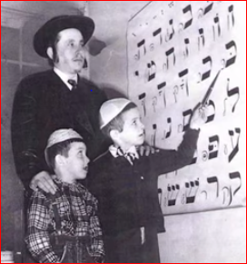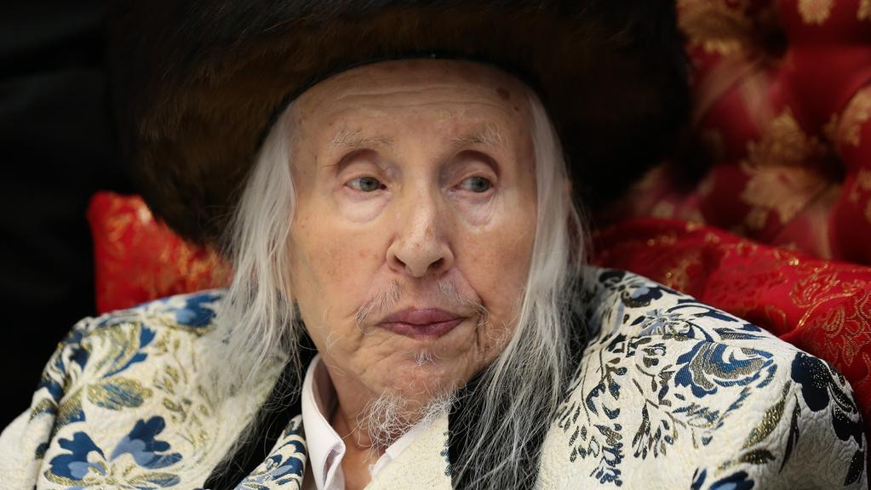
Rabbi Menachem Mendel Taub, in the 1950s and in recent years.

He needed some donations for a Sefer Torah. The Torah cost $3,500 at the time. His grandmother pledged to sponsor the entire Torah, a great feat in those days and she asked for one thing in return. She asked the rabbi to say a prayer for her ill grandson, Stuart on the first Shabbat with the Torah. Stuart eventually made a miraculous recovery after that.

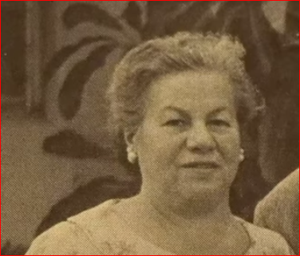
Stuart’s grandmother

Years later, the rav picked up the entire congregation of his shul, and made aliyah to Eretz Yisrael. That was the very same shul that Stuart and his friends walked into that morning and that was the very same Torah they were reading that Stuart witnessed that had saved Stuart’s life physically years before. Now that Torah had saved his life again, but this time spiritually! We must connect to the Torah, learn from it, and support it, because ultimately, Torah is what is supporting us!

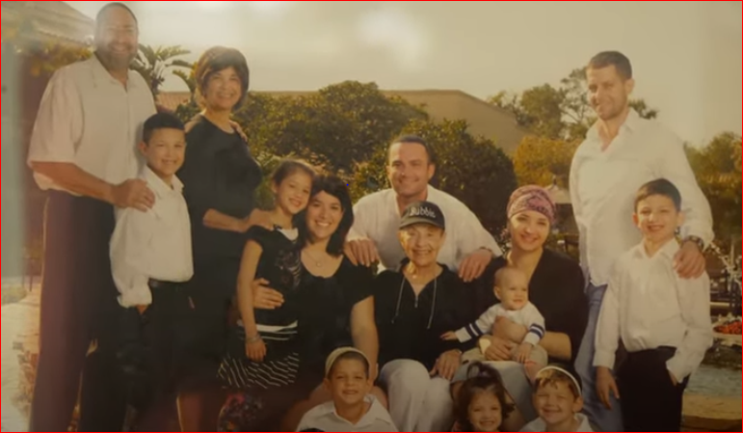
Stuart’s religious family today.

Reprinted from the Parashat Bamidbar 5780 email of Rabbi Amram Sananes as written by Jack E. Rahmey. To view the fascinating and inspiring five minute Yoel Gold video, click or google The Mysterious Sefer Torah by Rabbi Yoel Gold

